Week 03

Question 1:

Write a program to read two integer values and print true if both the numbers end with  the same digit, otherwise print false.

Example: If 698 and 768 are given, program should print true as they both end with 8.

**Sample Input 1**

25 53

**Sample Output 1**

false

**Sample Input 2**

27 77

**Sample Output 2**

true

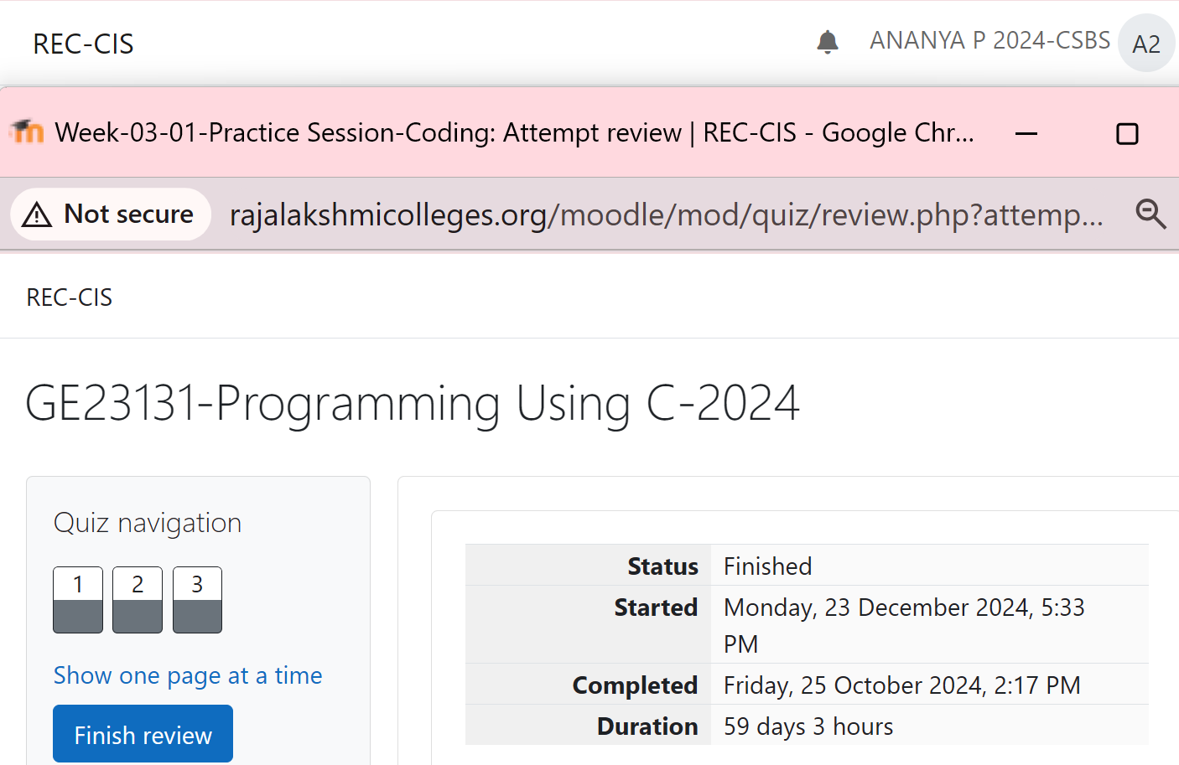

Program:

Output:

Question 2:

In this challenge, we're getting started with conditional statements.

**Task**

Given an integer, ***n***, perform the following conditional actions:

• If ***n*** is odd, print Weird

• If ***n*** is even and in the inclusive range of ***2*** to ***5***, print ***Not Weird***

• If ***n*** is even and in the inclusive range of ***6*** to ***20***, print ***Weird***

• If ***n*** is even and greater than ***20***, print ***Not Weird***

Complete the stub code provided in your editor to print whether or not ***n*** is weird.

**Input Format**

A single line containing a positive integer, ***n***.

**Constraints**

• 1 < n < 100

**Output Format**

Print Weird if the number is weird; otherwise, print Not Weird.

**Sample Input 0**

3

**Sample Output 0**

Weird

Program:

Output:

Question 3:

Three numbers form a Pythagorean triple if the sum of squares of two numbers is equal to  the square of the third.

For example, 3, 5 and 4 form a Pythagorean triple, since 3*3 + 4*4 = 25 = 5*5

You are given three integers, a, b, and c. They need not be given in increasing order. If  they form a Pythagorean triple, then print "yes", otherwise, print "no". Please note that the  output message is in small letters.

**Sample Input 1**

3

5

4

**Sample Output 1**

Yes

Program:

Output:

Question 4:

Write a program that determines the name of a shape from its number of sides. Read the  number of sides from the user and then report the appropriate name as part of a  meaningful message. Your program should support shapes with anywhere from 3 up to  (and including) 10 sides. If a number of sides outside of this range is entered then your  program should display an appropriate error message.

**Sample Input 1**

3

**Sample Output 1**

Triangle

**Sample Input 2**

7

**Sample Output 2**

Heptagon

**Sample Input 3**

11

**Sample Output 3**

The number of sides is not supported.

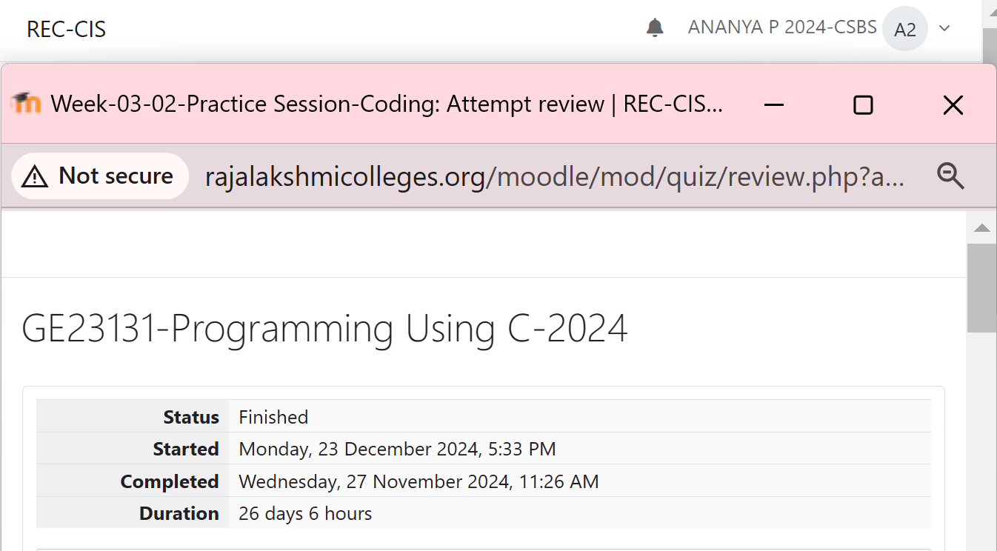

Program:

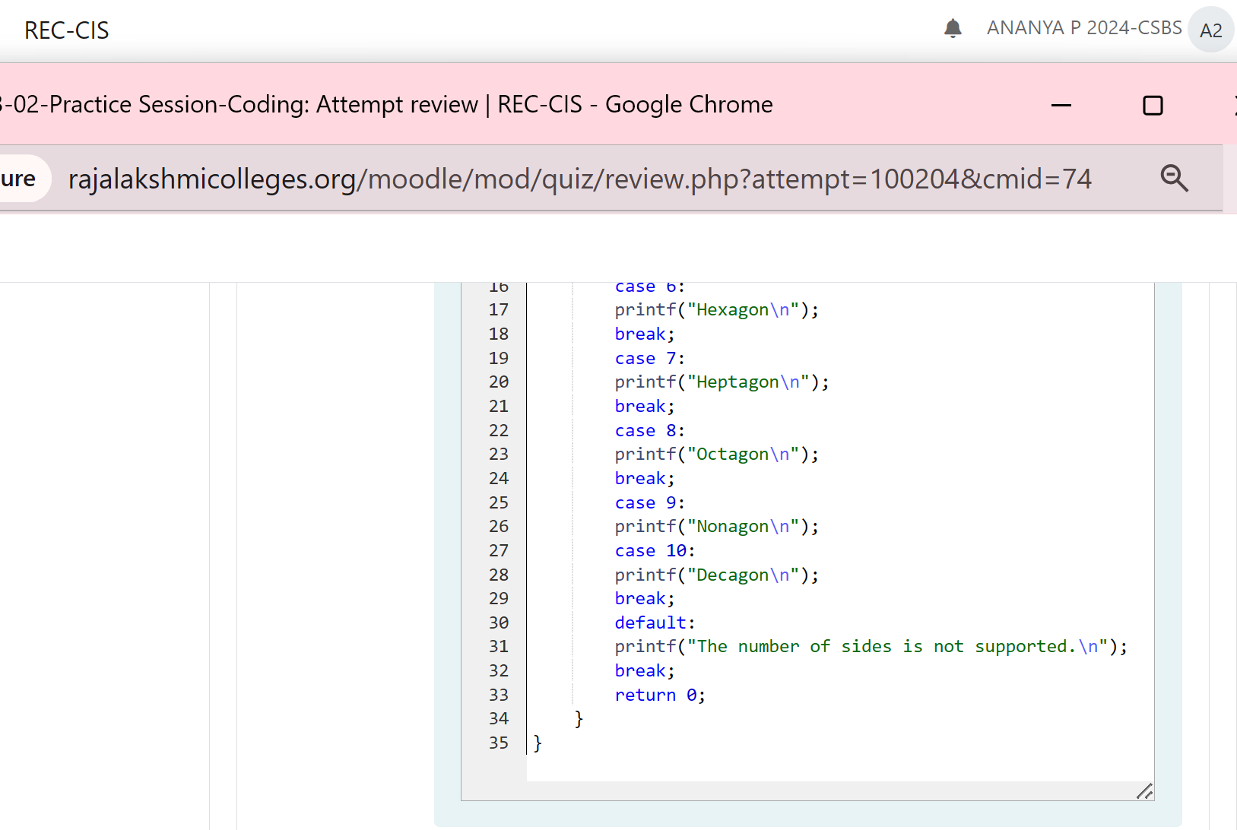

Output:

Question 5:

The Chinese zodiac assigns animals to years in a 12-year cycle. One 12-year cycle is  shown in the table below. The pattern repeats from there, with 2012 being another year of  the Dragon, and 1999 being another year of the Hare.

**Year Animal**

2000 Dragon

2001 Snake

2002 Horse

2003 Sheep

2004 Monkey

2005 Rooster

2006 Dog

2007 Pig

2008 Rat

2009 Ox

2010 Tiger

2011 Hare

Write a program that reads a year from the user and displays the animal associated with  that year. Your program should work correctly for any year greater than or equal to zero,  not just the ones listed in the table.

**Sample Input 1**

2004

**Sample Output 1**

Monkey

**Sample Input 2**

2010

**Sample Output 2**

Tiger

Program:

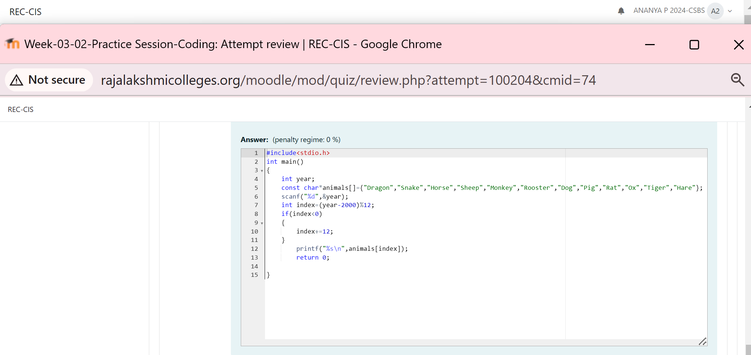

Output:

Question 6:

Positions on a chess board are identified by a letter and a number. The letter identifies the  column, while the number identifies the row, as shown below:

Write a program that reads a position from the user. Use an if statement to determine if the  column begins with a black square or a white square. Then use modular arithmetic to  report the color of the square in that row. For example, if the user enters a1 then your  program should report that the square is black. If the user enters d5 then your program  should report that the square is white. Your program may assume that a valid position will  always be entered. It does not need to perform any error checking.

**Sample Input 1**

a 1

**Sample Output 1**

The square is black.

**Sample Input 2**

d 5

**Sample Output 2**

The square is white.

Program:

Output:

Question 7:

Some data sets specify dates using the year and day of year rather than the year, month,  and day of month. The day of year (DOY) is the sequential day number starting with day 1  on January 1st.

There are two calendars - one for normal years with 365 days, and one for leap years with  366 days. Leap years are divisible by 4. Centuries, like 1900, are not leap years unless  they are divisible by 400. So, 2000 was a leap year.

To find the day of year number for a standard date, scan down the Jan column to find the  day of month, then scan across to the appropriate month column and read the day of year  number. Reverse the process to find the standard date for a given day of year. Write a program to print the Day of Year of a given date, month and year.

Sample Input 1

18

6

2020

Sample Output 1

170

Program:

Output:

Question 8:

Suppandi is trying to take part in the local village math quiz. In the first round, he is asked  about shapes and areas. Suppandi, is confused, he was never any good at math. And also,  he is bad at remembering the names of shapes. Instead, you will be helping him calculate  the area of shapes.

• When he says rectangle, he is actually referring to a square.

• When he says square, he is actually referring to a triangle.

• When he says triangle, he is referring to a rectangle

• And when he is confused, he just says something random. At this point, all you can  do is say 0.

Help Suppandi by printing the correct answer in an integer.

**Input Format**

• Name of shape (always in upper case R **-->** Rectangle, S -**->** Square, T **-->** Triangle) • Length of 1 side

• Length of other side

**Note**: In case of triangle, you can consider the sides as height and length of base

**Output Format**

• Print the area of the shape.

**Sample Input 1**

T

10

20

**Sample Output 1**

200

Program:

Output:

Question 9:

Superman is planning a journey to his home planet. It is very important for him to know  which day he arrives there. They don't follow the 7-day week like us. Instead, they follow  a 10-day week with the following days:

**Day Number Name of Day**

1 Sunday

2 Monday

3 Tuesday

4 Wednesday

5 Thursday

6 Friday

7 Saturday

8 Kryptonday

9 Coluday

10 Daxamday

Here are the rules of the calendar:

• The calendar starts with Sunday always.

• It has only 296 days. After the 296th day, it goes back to Sunday.

You begin your journey on a Sunday and will reach after n. You have to tell on which day  you will arrive when you reach there.

**Input format:**

• Contain a number n (0 < n)

**Output format:**

Print the name of the day you are arriving on

**Sample Input**

7

**Sample Output**

Kryptonday

**Sample Input**

1

**Sample Output**

Monday

Program:

Output:

